Digital Signal Processing
Year : 2016-17 Div : B.E. A,B,C
Lecture – 07

- Write equation for linear convolution.
If x1[n] = [1, 2, 3, 4, 6] and x2[n] = [1, -1, 2, 0, 3, -2] then find y[n] = x2 *x2[n].
- Explain linearity property of convolution.
- Find linear convolution of following signals:
  - x1[n] = [1, -2, 0, 4] and x2[n] = [1, -1, 1]
  - x1[n] = [1, -2, 0, 4] and x2[n] = [1, -1, 1]
  - x1[n] = [-1, 5.5, 0.2] and x2[n] = [1, 1, 1]
  - x1[n] = u[n]-u[n-5] and x2[n] = u[n]-u[n-2]

Q2.)

Associativity

THEOREM 1: Associative Law

f₁(t)*(f₂(t)*f₃(t))=(f₁(t)*f₂(t))*f₃(t)(1)

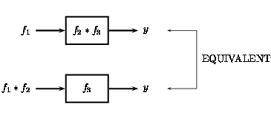
Figure 1: Graphical implication of the associative property of convolution.

Commutativity

THEOREM 2: Commutative Law

y(t) | = | f(t)*h(t)
 | = | h(t)*f(t)
(2)

PROOF
To prove Equation 2, all we need to do is make a simple change of variables in our convolution integral (or sum),
y(t)=∫_{−∞}∞f(τ)h(t−τ)dτ(3)
By letting τ=t−τ, we can easily show that convolution is commutative:
y(t) | = | ∫_{−∞}∞f(t−τ)h(τ)dτ
 | = | ∫_{−∞}∞h(τ)f(t−τ)dτ
(4)
f(t)*h(t)=h(t)*f(t)(5)

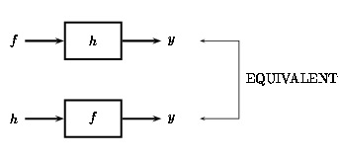
Figure 2: The figure shows that either function can be regarded as the system's input while the other is the impulse response.

Distribution

THEOREM 3: Distributive Law

f₁(t)*(f₂(t)+f₃(t))=f₁(t)*f₂(t)+f₁(t)*f₃(t)(6)

PROOF
The proof of this theorem can be taken directly from the definition of convolution and by using the linearity of the integral.
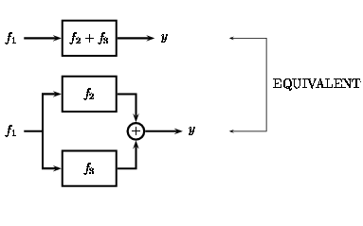
Figure 3

Time Shift

THEOREM 4: Shift Property
For c(t)=f(t)*h(t), then
c(t−T)=f(t−T)*h(t)(7)
and
c(t−T)=f(t)*h(t−T)(8)

(a)
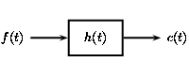

(b)
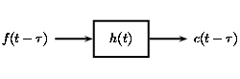

(c)
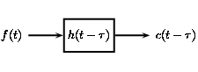

Figure 4: Graphical demonstration of the shift property.

